Flow Charts / Task Graphs
# Source: AI Source: Provided by: [Data Path: Persons Table -> ID Column: 1, Name_En Column: Motasem Essam] -> From: [ChatGPT] on [1/21/2026]
Flow Charts / Task Graphs are another common modeling technique in Real-Time Systems (RTS) used to represent tasks, their execution order, and dependencies. They help in designing, analyzing, and scheduling tasks in software engineering.

Definition
# Source: AI Source: Provided by: [Data Path: Persons Table -> ID Column: 1, Name_En Column: Motasem Essam] -> From: [ChatGPT] on [1/21/2026]
- Flow Chart: A diagram representing the sequence of operations or tasks using symbols like arrows, boxes, and diamonds.
- Task Graph: A directed graph where nodes represent tasks and edges represent dependencies or communication between tasks.
These diagrams help in visualizing task execution flow, parallelism, and inter-task dependencies.

Key Features
# Source: AI Source: Provided by: [Data Path: Persons Table -> ID Column: 1, Name_En Column: Motasem Essam] -> From: [ChatGPT] on [1/21/2026]
- Nodes
  - Represent tasks, processes, or operations.
  - Can include execution time, priority, or resource requirements.
- Edges
  - Represent task dependencies, communication, or sequence.
  - Indicates which tasks must finish before others start.
- Parallelism and Concurrency
  - Multiple independent tasks can be executed simultaneously if no dependency exists.
- Deadlines and Timing Analysis
  - Task graphs can include start times, deadlines, and execution durations for scheduling.

Example
# Source: AI Source: Provided by: [Data Path: Persons Table -> ID Column: 1, Name_En Column: Motasem Essam] -> From: [ChatGPT] on [1/21/2026]
Suppose we have three tasks:
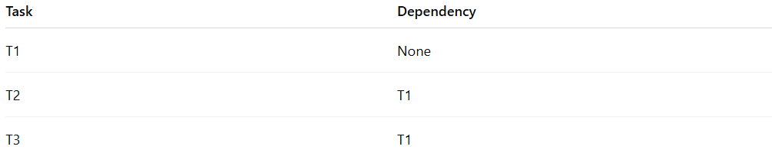
Task | Dependency
T1 | None
T2 | T1
T3 | T1
Task Graph:
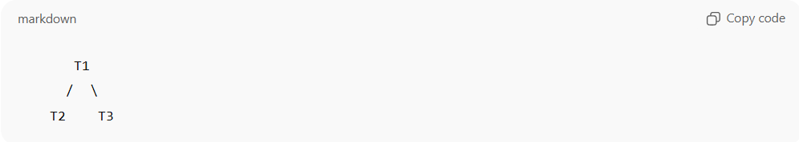
T1
/ \
T2 T3
- T1 executes first.
- T2 and T3 can run in parallel after T1 completes.
Flow Chart:
- Shows start → T1 → decision → T2 & T3 → end, using standard flowchart symbols.

Advantages
# Source: AI Source: Provided by: [Data Path: Persons Table -> ID Column: 1, Name_En Column: Motasem Essam] -> From: [ChatGPT] on [1/21/2026]
- Visualizes task dependencies and execution order
- Helps in parallelism analysis
- Useful for real-time scheduling and resource allocation

Disadvantages
# Source: AI Source: Provided by: [Data Path: Persons Table -> ID Column: 1, Name_En Column: Motasem Essam] -> From: [ChatGPT] on [1/21/2026]
- Complex for large systems with many tasks
- May require additional timing diagrams to analyze deadlines

Applications
# Source: AI Source: Provided by: [Data Path: Persons Table -> ID Column: 1, Name_En Column: Motasem Essam] -> From: [ChatGPT] on [1/21/2026]
- Embedded system task design
- Real-time scheduling analysis
- Workflow modeling in industrial automation
- Software engineering for RTS

